Project Planning Phase
Project Planning Template (Product Backlog, Sprint Planning, Stories, Story points)

Date | 18 October 2026
Team ID | Individual
Project Name | EV Market Performance & Sustainability Analytics
Maximum Marks | 8 Marks

Product Backlog, Sprint Schedule, and Estimation (4 Marks)
Use the below template to create product backlog and sprint schedule
Sprint | Functional Requirement (Epic) | User Story Number | User Story / Task | Story Points | Priority | Team Members

Project Tracker, Velocity & Burndown Chart: (4 Marks)
Sprint | Total Story Points | Duration | Sprint Start Date | Sprint End Date (Planned) | Story Points Completed (as on Planned End Date) | Sprint Release Date (Actual)
Sprint-1 | 8 | 6 days | 24 Oct 2026 | 29 Oct 2026 | 8 | 29 Oct 2026
Sprint-2 | 8 | 6 days | 31 Oct 2026 | 05 Nov 2026 | 8 | 05 Nov 2026
Sprint-3 | 8 | 6 days | 07 Nov 2026 | 12 Nov 2026 | 8 | 12 Nov 2026
Sprint-4 | 8 | 6 days | 14 Nov 2026 | 19 Nov 2026 | 8 | 19 Nov 2026

Velocity:
Project planning estimate: 32 story points are planned across four sprints. Using an illustrative 6-day sprint and 8 completed story points per sprint, estimated average velocity = 8 / 6 = 1.33 story points per workday. This is a planning assumption, not measured historical velocity.


Burndown Chart:
A burn down chart is a graphical representation of work left to do versus time. It is often used in agile software development methodologies such as Scrum. However, burn down charts can be applied to any project containing measurable progress over time.

https://www.visual-paradigm.com/scrum/scrum-burndown-chart/
https://www.atlassian.com/agile/tutorials/burndown-charts

Reference:
https://www.atlassian.com/agile/project-management
https://www.atlassian.com/agile/tutorials/how-to-do-scrum-with-jira-software
https://www.atlassian.com/agile/tutorials/epics
https://www.atlassian.com/agile/tutorials/sprints
https://www.atlassian.com/agile/project-management/estimation
https://www.atlassian.com/agile/tutorials/burndown-charts

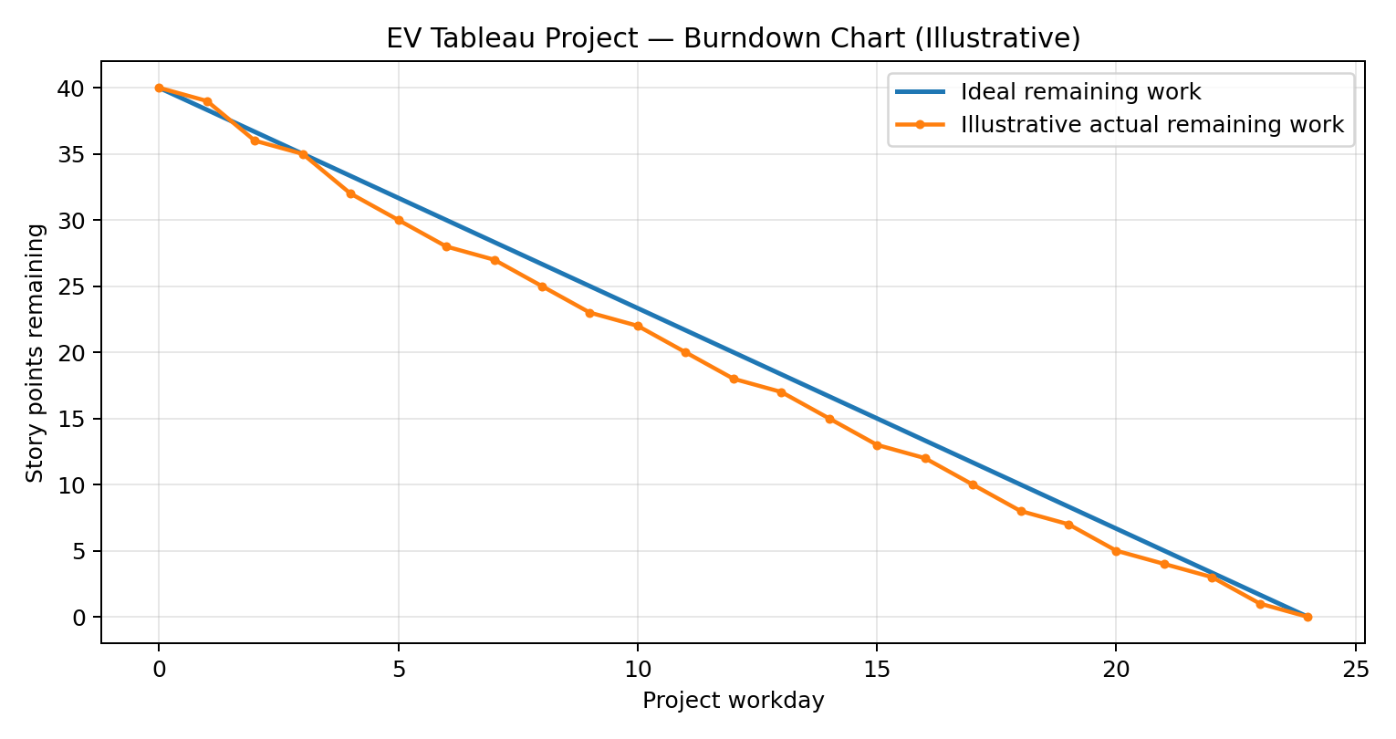
Note: Actual progress line is illustrative because daily completed-work data was not supplied.

